INTRODUCTION –Power BI is a powerful business analytics tool developed by Microsoft that enables users to visualize data, share insights, and make informed decisions.

In this project we will analyse 19 years of Indian Agriculture Data to find various parameters of crop production, prediction based on post data and minimum support price for the given crop for the given year. The project will be understand basics of data analytics, power BI and related concepts.

STEP 1 - Power BI downloading process is straightforward from official Microsoft website.

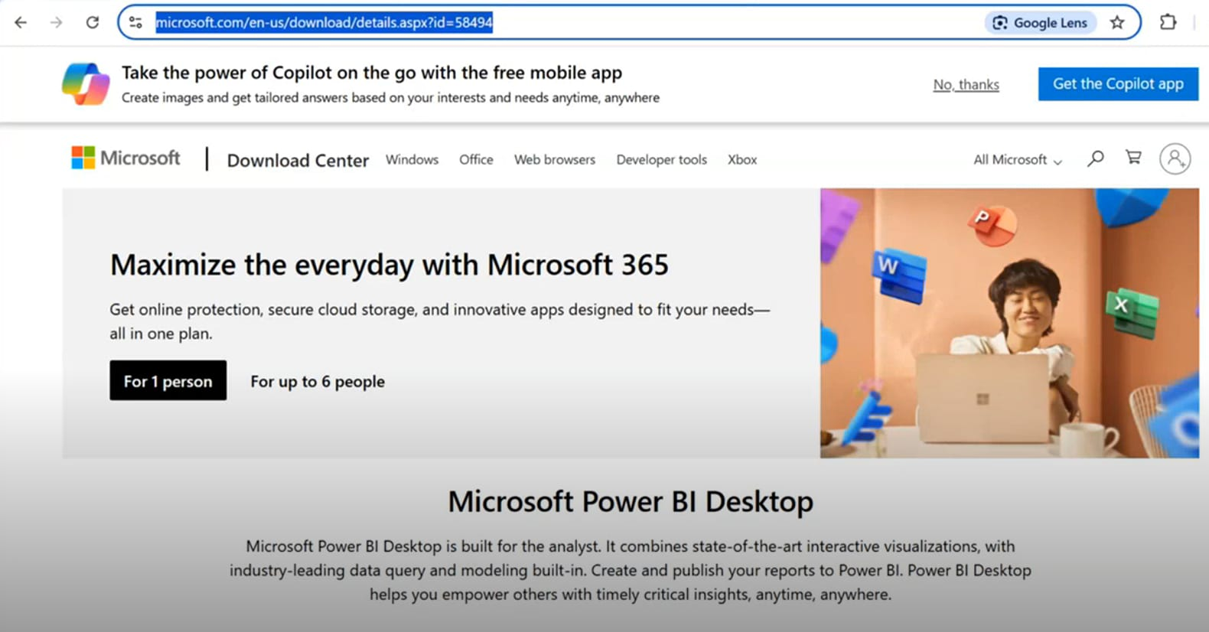

Step 2 – Open the Blank Report and canvas will be opened.

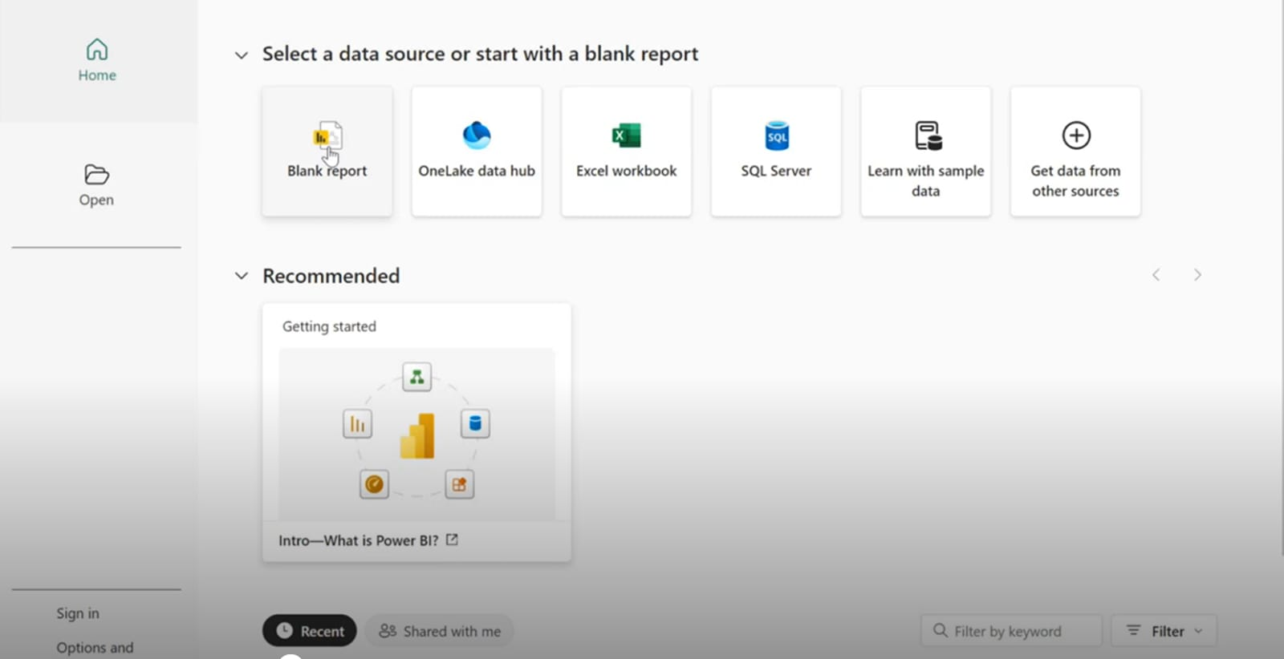

Step 3 –open the file from your saved documents whether it was a CSV file or excel sheet or in other format.

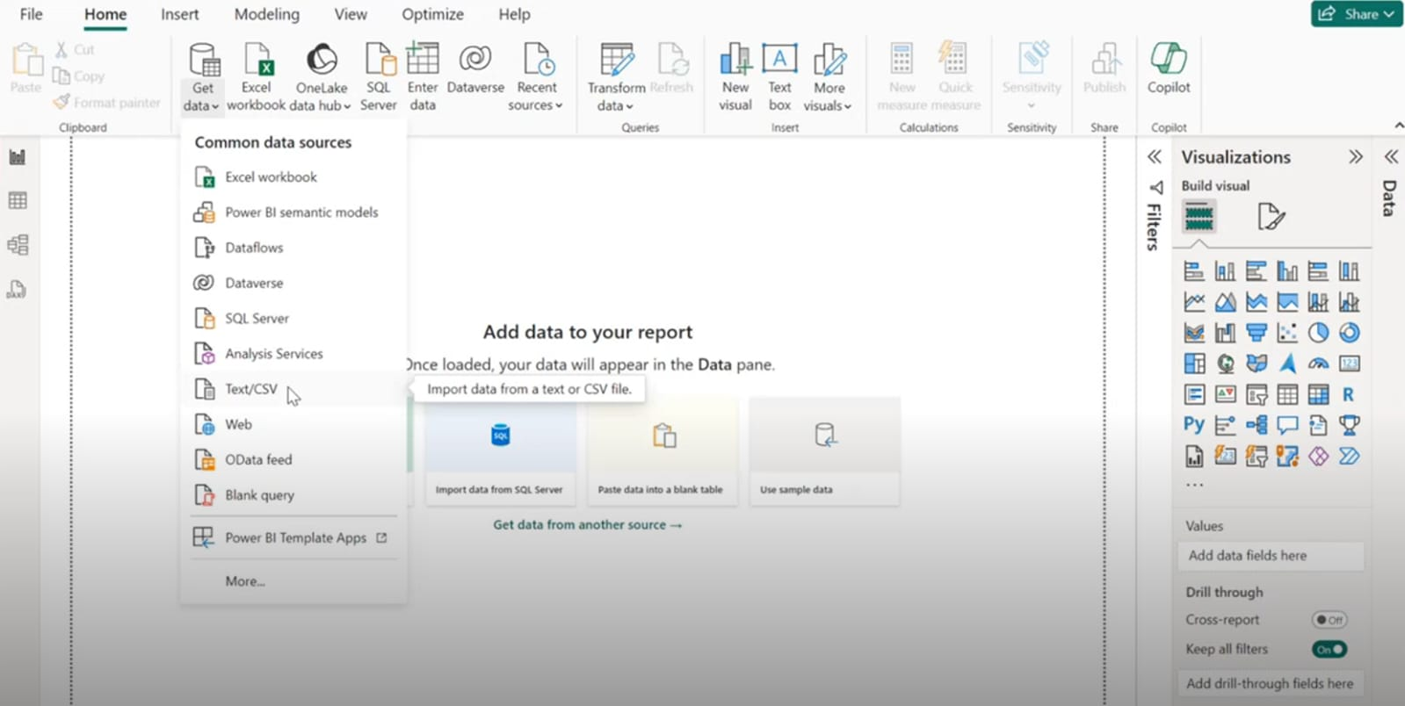

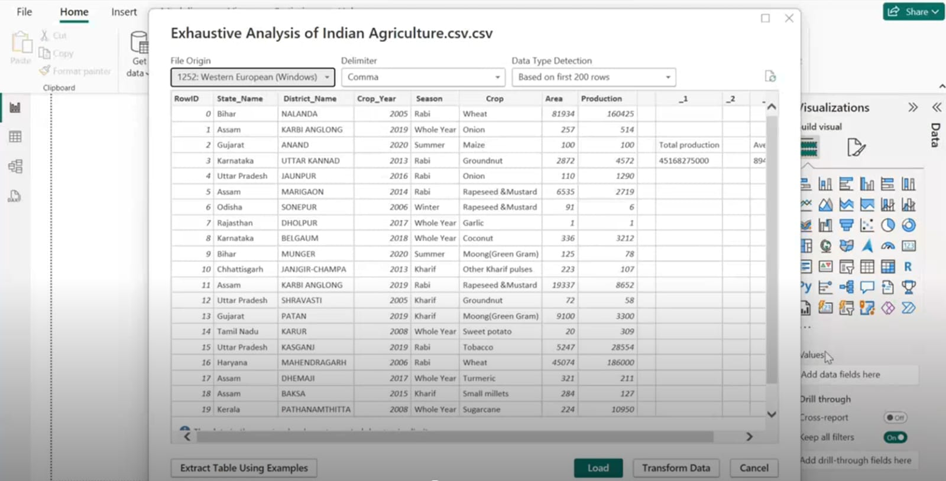 Step4 –Once file will open there are two options first you can transform your data and secondary you can load your data.

Step 5- after performing transform action you can remove rows and columns as well as blank rows and also select multiple rows , transforming is done when you want to process the data.

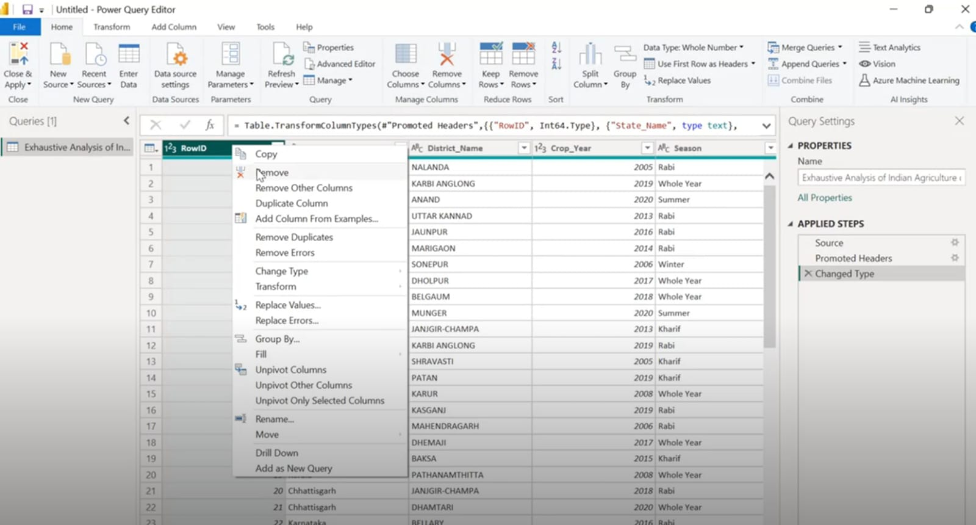

Step 6 -if user by mistake deleted any rows or columns you can undo it by clicking on the cross.

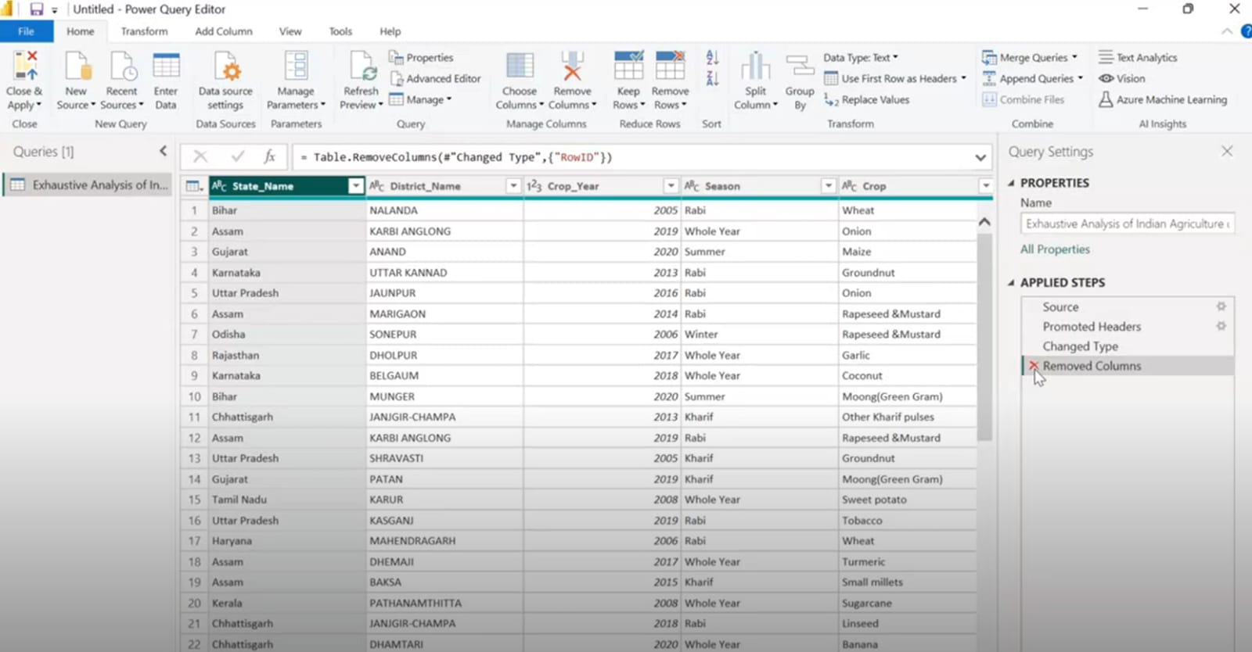

Step 7 – after performing load action, you can view your data by report view, table view and model view in the left side of canvas. Load is used when the data is cleaned and user want view the data in different format.

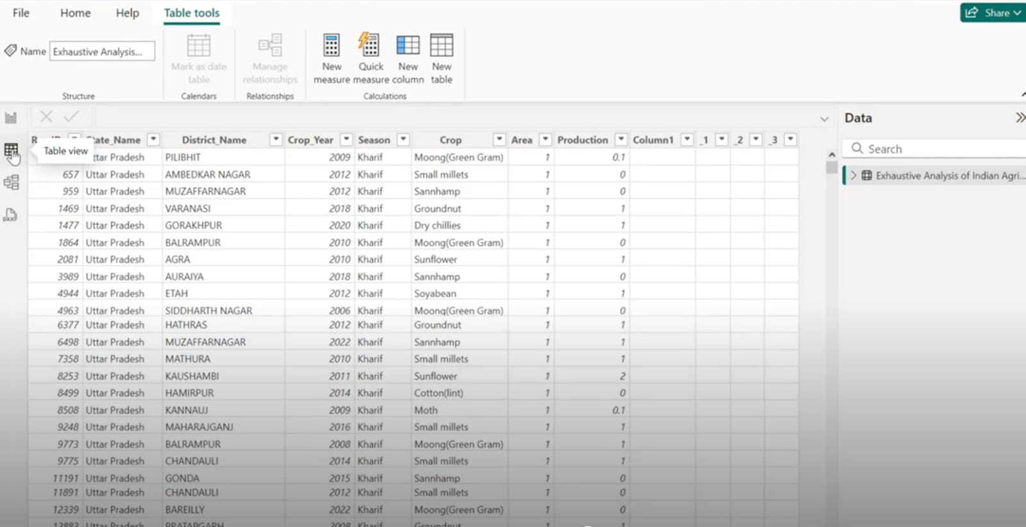

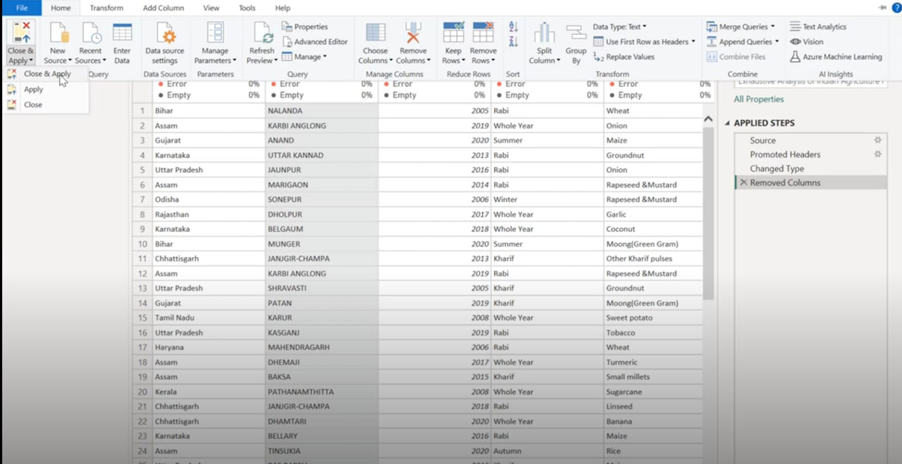Step 8 -after performing all the steps you can close and apply and the file data have been saved now you can save your file in your device.